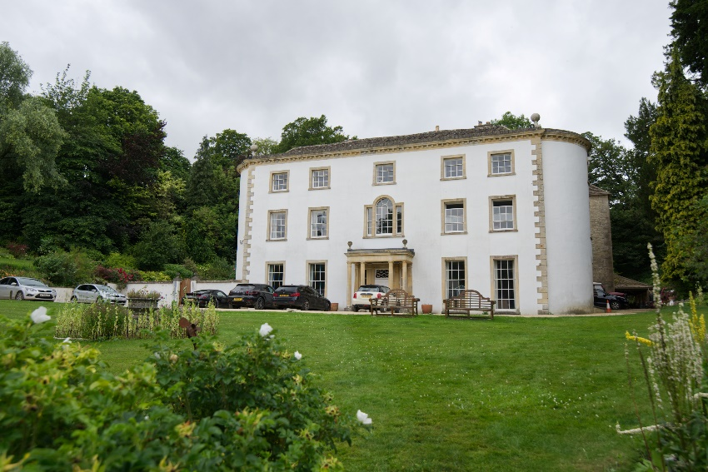
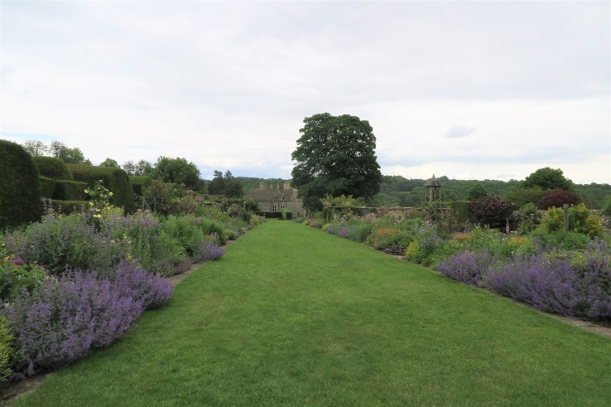
Miserden Park & Cerney House Gardens, 23rd June 2021, 9.15-18.30
Two stunning Cotswold gardens:
Miserden. Step back into the Edwardian era in this Lutyens inspired garden, described as ‘gorgeous, timeless’. Set in the heart of the Cotswolds, Miserden’s gardens were first laid out in the C17th with formal terraces overlooking its Golden Valley, along with walled gardens behind the house. Much of this structure survives, albeit in softened form. The walled garden contains one of the longest herbaceous borders in Britain (pictured left), alongside a yew walk and flanking garden rooms culminating in a parterre garden. A recent addition has been the Millennium Garden with a summerhouse and fountain pool. A small arboretum ties in the garden to the well-wooded parkland in the valley below. There is a well-stocked nursery and the Glasshouse Café, in which lunch may be taken. Miserden won the Historic Gardens Association ‘Garden of the Year’ in 2018.
Cerney House (right) is set in an equally tranquil, private valley. Again, it is a garden largely set within its walled kitchen garden, but now planted with a riot of herbaceous plants and old-fashioned roses. These borders lead to a formal knot garden and to further mixed vegetable and ornamental planting on the banks. Below the house are further lawned areas, an avenue and shrub borders. Tea is included in the price.

***************************************************************************************************************************
Miserden & Cerney House 23rd June 2021, 9.25-17.45
Name(s): ………………………………………………………………………………………………
e-mail address……………………………………….Telephone:………………………………………
I wish to book ……. members tickets on the minibus @ £30.00 and …… guest tickets @ £35.00
I will find my own way and require ….. members tickets @£20 and …… guest tickets @ £25
I wish to book …. lunch places at Miserden @£15/head OR I wish to book …. places at the Carpenters Arms..
Please return with cheque made payable to Warwickshire Gardens Trust to:
Matt Fattorini, 10-12, Portland Place West, Leamington Spa, CV32 5EU. mattfattorini@gmail.com (07956 571287)

