
Visit to Hagley Hall and Park (DY9 9LQ), 18th May 2021, 10.45-16.30
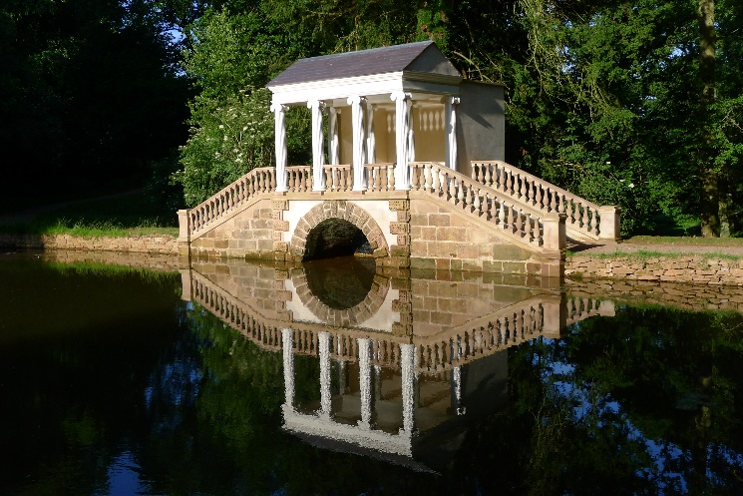
Following on from Joe Hawkins’ inspirational talk about the restoration of the park at Hagley, we have been invited for a rare, guided tour of the house, followed by a tour of the park led by Joe.
Laid out by the poet/politician George, 1st Lord Lyttleton between 1747 & 1758, Hagley was one of the most celebrated of the new ‘natural landscape gardens’ of the C18. Set in a natural bowl, its many streams were given life by a series of artificial cascades, some of which owe their recent rediscovery to Joe. Within the landscape were seats and urns (now mainly lost) dedicated to famous poets, including Milton, Pope and Lyttleton’s gardening neighbour William Shenstone; a Grecian temple designed by ‘Athenian’ Stewart – his earliest commission on returning from Athens; and Sanderson Miller’s Ruined Gothic Castle, a building much admired by Horace Walpole for showing the “true rust of the Baron’s War”. The Palladian Bridge (above) has recently been restored as part of the new Viscount Cobham’s commitment to restore the park after 210 years’ neglect.
Sanderson Miller was also largely responsible for the design of the mansion, one of his greatest masterpieces. Built 1754-60, it is home to magnificent decorative plasterwork by Francesco Vassalli, as well as paintings and furniture collected on George Lyttleton’s Grand Tour and later. The church, rebuilt by Sanderson Miller and again by George Street, is also worth visiting. It houses Roubilliac’s funerary monument to Lord Lyttleton.

N.B. This tour is limited to 20 spaces. Members will be given priority.
Meet 10.45 at St. John the Baptist Church, Hagley, for 11.a.m. house tour (1-1.5) hours. Lunch in local pubs or picnic in car park. Meet St. John the Baptist for 1.45 p.m. tour of park (2 hours +). 4 p.m. Tea and biscuits.
Directions: M40(N) to M42 and M5(N). Leave M5 at J4 and take A491 towards Stourbridge. After c. 5+ miles take 5th exit at roundabout onto Park Road (N.B. DO NOT TAKE 3RD EXIT, also Park Road). At end of road turn left then immediately right on to Hall Lane and continue to church. From Leamington/Warwick c.55 mins.
----------------------------------------------------------------------------------------------------------------------------------------------------------
Hagley Hall and Park – Guided Tour May 18th, 2021.

Name(s) ..

Phone number Email

I wish to book Places @ £25.00 for members, (Non-Members.......Places @£30.00. See above!)

Please make cheques payable to Warwickshire Gardens Trust and send to: Mrs. Penelope Jane Nash,2 Farm Close, Harbury, Leamington Spa, CV33 9LL (Organizer: mattfattorini@gmail.com (07956 571287))

